Sources on Alexander the Great
Note: This was transcribed from handwritten notes based on either Hamilton or Bosworth.
- Controversial figure.
- Conflicting evidence.
- Greek education, promoted Hellenisation.
- Heredity and background important.
- Turning point in Greek history.
- Empire ended with death.
- Tarn describes Alexander like Hitler.
Arrian: “Accounts of Alexander were more numerous and more confusing than any other historical figure.”

Primary sources
Callisthenes:- Aristotle’s nephew, official historian, already had established reputation as a writer. Only approved material. Heroic portrayal (recalling Achilles). Propaganda.
Chares:- Proskynesis, Cleitus’ murder. Historical romance/novel, blend fact and fiction. (Onesicritus)
Nearchus:- Admiral, account of the voyage from the Indus to the Persian Gulf. “Did ot seek to draw a detailed picture of Alexander.”
Ptolemy:- History of Alexander written later in life. Omitted or misrepresented some Macedonian leaders (e.g. Perdiccus) who were his opponents in the wars of succession; attempt to conceal their position and elevate himself? Probably wrote after Cleitarchus. Does not discuss more controversial episodes – reverence, or part of his cult of Alexander. Invaluable military account, access to official documents. Later King of Egypt, so has own priorities.
Aristobulus:- Eighty-four when began writing. Apologetic: wote to defend Alexander’s memory. Denied heavy drinking. Geographical info and final year.
Cleitarchus:- Most popular, “sensational” account. Portrayal as a hero. Contradicts Ptolemy, so probably written afterwards (see H, p17).
Alexander – sensational hero, or fortunate villian?
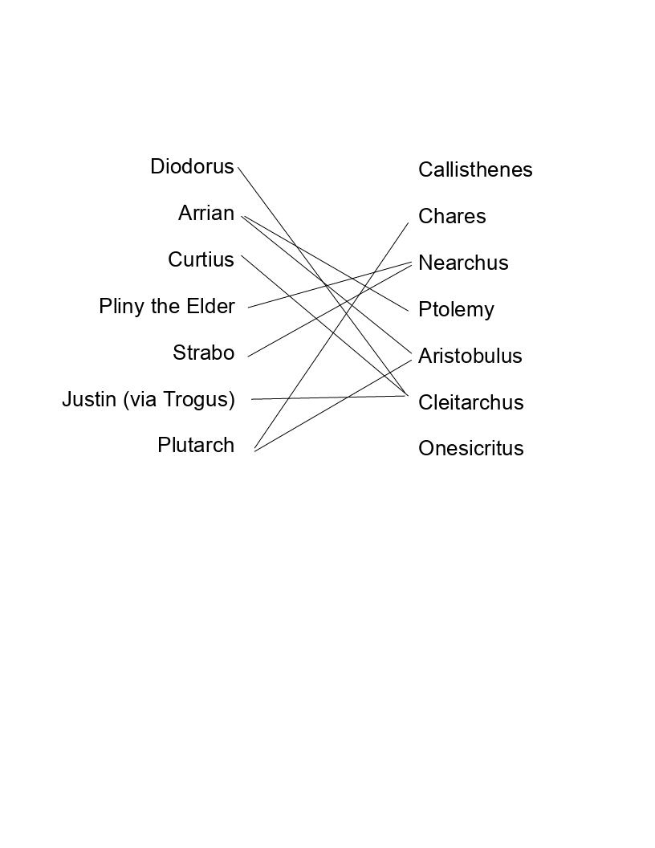

Secondary Sources
Diodorus:- Not apologetic (relating a series of massacres), detailed figures for Alexander’s forces, influence of fortune. “Successful statesmen are righteous.”
Curtius:- During the reign of Claudius (probably). Common source with Diodorus. Hatred of the ruler cult, sudden deterioration in Alexander’s character after death of Darius. Some military.
Arrian:- Based on Ptolemy and Aristobulus. Good for warfare/military, leadership qualities, criticism of ambition (dominant motive), misled by prejudices (e.g. cult of leadership only a propaganda device).
Plutarch:- Biographer, not historian. Concerned with character, rather than administrative or military achievements. Quotes from Alexander’s letters. Early life. Prone to explain any failings. Changed for the worse (like Arrian).
Justin via Trogus:- “Not much bread to an intolerable amount of sack.” Some info on Phillip’s last years.

In general, writers tended to concentrate on the person rather than the wider aspects of his reign. However, main issue is not lack of evidence – it is conflicting acounts (mainly between the “official” and the “vulgate” versions of events).
There is no definitive history of Alexander.

Greece vs. Macedon
Important cultural differences between Greece and Macedonia – Demosthenes called Phillip II a “barbarian”. However, Macedonians were decended from Greeks.
Nobility partially Helenised by the end of the 5th century BCE – Alexander I (495-450 BCE) was allwed to compete in the Olympics, and Euripedes’ Bacchae was written in Pella. Nobles were more interested in hunting and fighting than in theatre and arts, and drank unwatered wine.
Both Greeks & Macedonians thought themselves superior to the other.

Leadership in Macedon
King bound by the Companions (nobles who protected him in war and served him in battle); first among equals.
Nobles were not hesitant to speak their minds. In practic, king not absolute.
Strong leadership needed as Macedonia acted as a barrier between civilised Greece and Thrace, Illyria, etc.

Birth and Early Life
- Born 356 BCE
- Father: Phillip II of Macedon
  - Claimed descent from Heracles
- Mother: Olympia of Epirus
  - Claimed descent from Achilles and Andromache
- Raised to be intelligent, strategist
- Tutor was Aristotle
- Enjoyed Homeric epics, kept Iliad with him for entire life
- Arrogant

Attalus
- Phillip marries Cleopatra, daughter of Attalus.
- Attalus: “Finally, a legitimate heir”
- Alexander: “Am I a bastard, you villain?”
Phillip drew sword to attach Alexander, but trips - “the man preparing to cross from Europe into Asia cannot cross from couch to couch”.

Death of Phillip
- Wedding of Phillip II & Olympias’ daugher Cleopatra to Alexander (king of Epirus).
- Wedding games: Pausanias, a Macedonan noblema, stabs the king in the chest (Diodorus).
- Diodorus/Plutarch/Justin/Aristotle: personal motive (Phillip took no action against a brutal assault many (eight) years before plotted by Attalus)
On the other hand, opportune moment for Alexander and Olympias – no question of who would succeed.

See also Plutarch’s Life.

